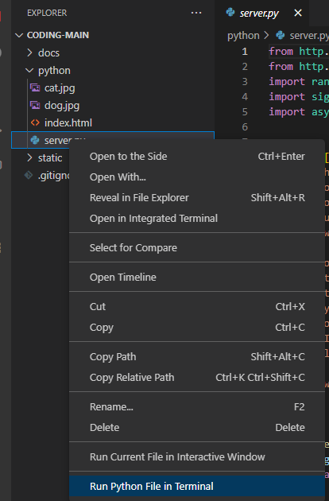
Setup

Right click on t he python/server.py and click the Run Python File in Terminal

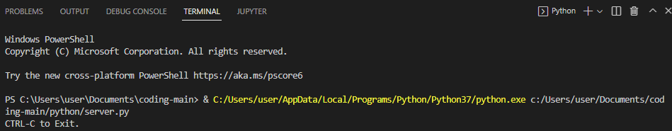

Start Edge or Chrome and visit this URL:

http://127.0.0.1:8080

Cat Quotes Website

This cat quotes web site is very much like the static one from last week, except the python code serves up the quote rather than having it inside the HTML

- It has a title: Cat Bible Quotes
- It has a cute cat photo
- It has a random quote in yellow

There are 4 files:

- server.py – This is a very simple python server that provides the random quote but also “hosts”
- the web site.
- The index.html is the file that Edge or Chrome will first read to display the web site
- The cat.jpg – is a cute cat picture
- The dog.jpg – is a cute dogs picture

Exercises

The following exercises are a bit more advanced and will require you to stop and restart the python
server.py script.

Restarting the python server requires you to click into the VSC Terminal and use the CTRL-C keys (CTRL + ‘C’ together), and it might take a few seconds to exit.

1. Add a new quote to the list
2. Change the server to always return the same quote
3. This one is extra hard: Change the server so it returns the quotes in order, one at a time each
time you refresh the page.
4. Even Harder, append a number to the end of the url (/quote/1) and return that quote from the list!

